AI Agent for Documentation and Summation
(Other Items)
Version 1.2
Team Members:
Abhisar Anand, Ali Mutlak, Brayan Cano, Dhyan Patel, Myles Edwards, Shar Min

Date | Version | Description | Name(s)
10/7/2025 | 1.0 | Preliminary Version | Ali Mutlak
11/8/2025 | 1.1 | Midterm Update | Ali Mutlak
12/08/2025 | 1.2 | Final Update | Brayan Cano

Resources & Technology

Resources:

- Visual Studio Code for dashboard
- GitHub for version control
- Discord/Outlook for team communication
- PC with a powerful GPU to run our programs locally (internal server)

Technology:

- TypeScript/React – App Development
- MongoDB – Database
- Git - Version Control
- OpenAI Whisper – Audio to Text Transcription
- Pyannote – audio diarization between two or more different speakers
- Tesseract – OCR
- Python – AI Agent & OCR
- FastAPI – web framework for python connectivity with dashboard and database
- Ollama Llama 3 – LLM for SOAP summarization and PII redaction

Software Verification Plan
Verification Team Lead: Brayan Cano
Every team member will be responsible for integrating unit tests within their code. Code reviews will be performed with the completion of sprints.

The test case for each portion of our project will be defined as a sprint, with its own expected completion day and results summary.

Verification Objectives:

Web Dashboard –

- Ensure authentication process controls access
- Visualization format correctness between varying screens
- In-transit and at-rest data is appropriately encrypted and protected
- Stability and user navigation
- API synchronization (speech to text, database, and OCR)
- Offline behavior is handled
- OCR performs within expected accuracy (CER < 1% on clean text, < 3% otherwise)

AI/ML Module –

- Model accuracy and recall (F1 score ≥ 0.8)
- Consistency of summations
- Accurate speech attribution
- Evaluate Whisper transcription pipeline accuracy (WER should be < ~10%)

Database –

- HIPPA Compliance with text storage
- Temporary audio storage
- Data Integrity

Stretch Requirements

- AI Summation processing before a visit is complete so that all participants may be handed a physical copy of the report.
- Multilingual support in both the OCR and speech to text transcriptions.
- Entirely self-contained.
- Statistics and analysis reports derived from the transcription and AI.
- Real time captions of audio to be displayed on the dashboard.
- Dynamic OCR, where processing differs depending on number of present users (between an on-client device, or server).

Estimated Hours to Complete Project

The project will likely take us the full scholarly year to complete. These estimates only approximate the number of hours spent on individual tasks, rounded together. They do not include meetings, in-person events, etc. It might be safe to assume an added hour for each week of work.
Total per Week ≈ 48 hours (8 each week per member)
Total for Fall Semester ≈ 115 days * 6.85 hours = 788 hours
Total for Spring Semester ≈ 121 days * 6.85 hours = 829 hours

Total ≈ 1,617 hours

Project Feasibility

The team has collectively agreed that this project is feasible, in consideration of the timeframe and estimated hours.

Prototype
(Clinical Application)

Once a user is logged in (in this example, a doctor), their username is displayed, the current date, and a general overview page is shown. The specifics of this page may vary depending on different subjects/environments applied, but in this case, it includes, a weekly summary of relevant stats, the most recent activities, the # of documents processed, the # of transcripts, the Average processing time, and the Accuracy Rate of our Models.
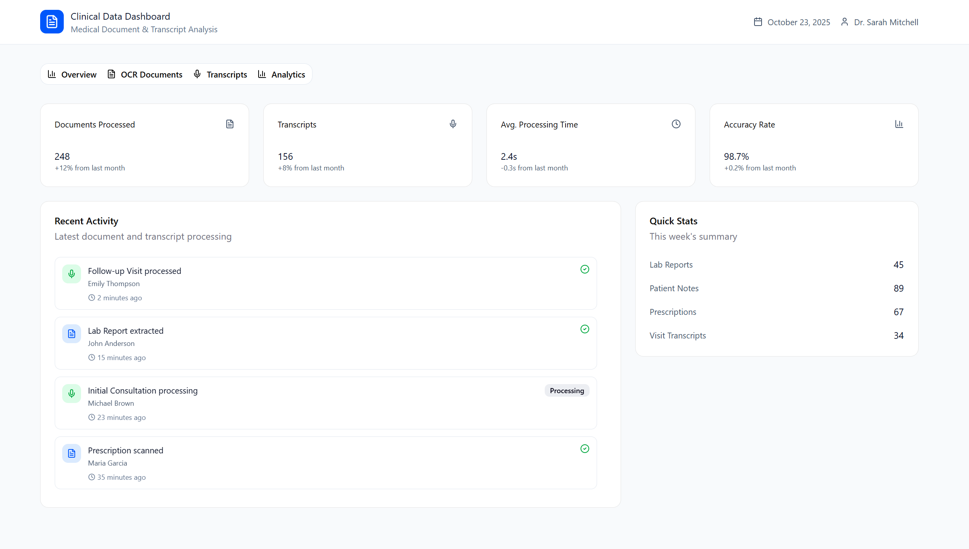

The next relevant page is for OCR Documents. If a doctor has processed an picture of some kind through our OCR, all included information like text, accuracy and derivations are shown.
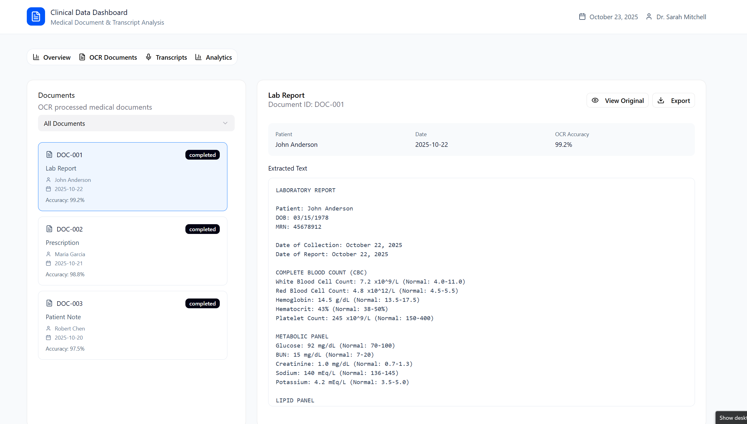

The transcripts page displays all of the audio files that were processed, and all relevant information. Doctor and patients can see full transcripts, while admins are only allowed to see transcripts with PII that has been redacted.

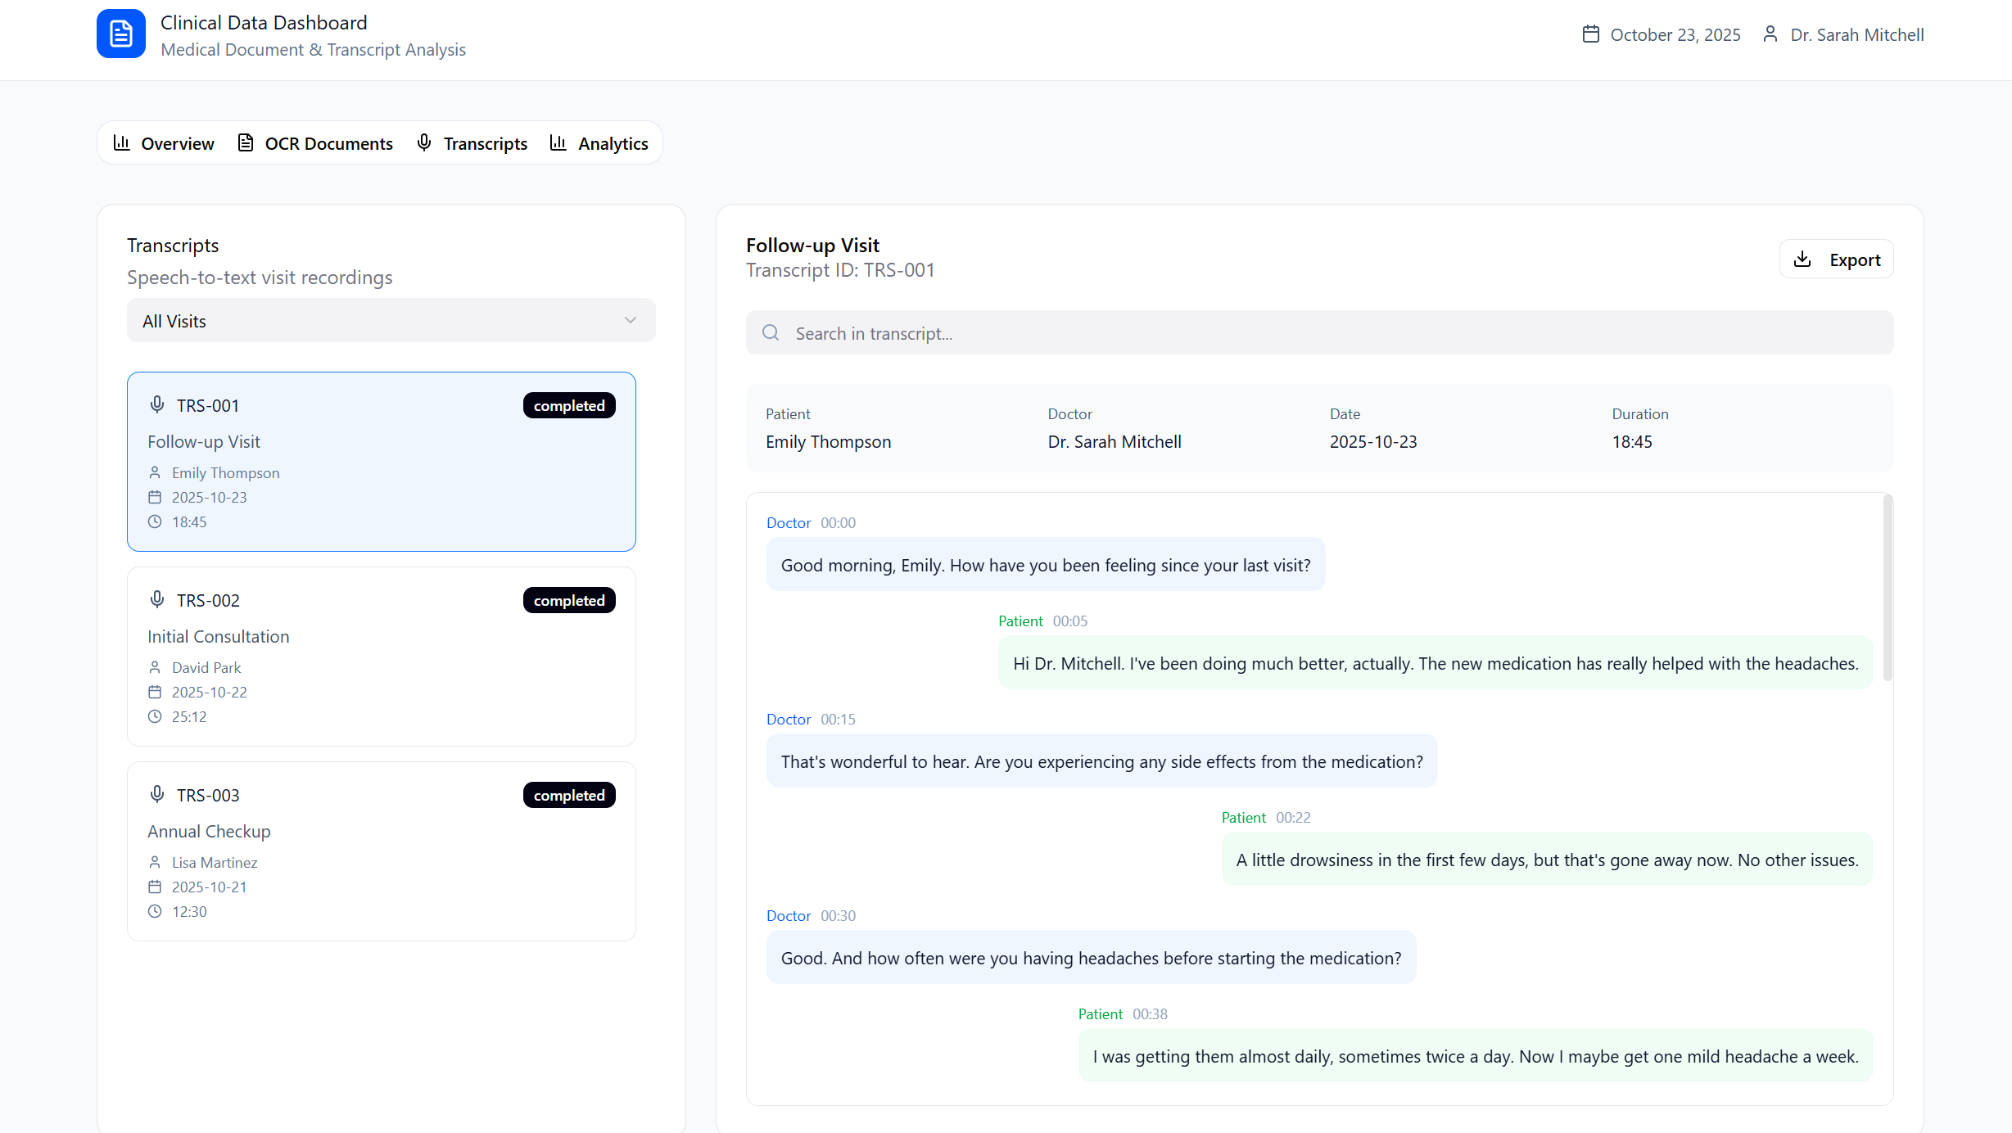

The final page for displaying information is the Analytics page. This essentially takes the data we have (OCR, Transcriptions, and AI Agent summaries) and derives more from it for general usage.

